|  |
| --- |
| GATE |
| **COA** |
| Short Notes and PYQ’s |

|  |
| --- |
| VARUN KUMAR  [Date] |

Table of Contents

**Floating Point Representation** 2

Notes 2

PYQ’s 3

**I/O Organization** 4

Notes 4

PYQ’s 5

**Memory Management** 6

**Cache Organization** 7

**DISK** 8

**Pipeline Processing** 9

**Instruction & Addressing Mode** 10

**CPU & Control Unit** 11

# **Floating Point Representation**

## Notes

## PYQ’s

# **I/O Organization**

## Notes

## PYQ’s

**2025**

Q.11 Suppose a program is running on a non-pipelined single processor computer system. The computer is connected to an external device that can interrupt the processor asynchronously. The processor needs to execute the interrupt service routine (ISR) to serve this interrupt. The following steps (not necessarily in order) are taken by the processor when the interrupt arrives:

(i) The processor saves the content of the program counter.

(ii) The program counter is loaded with the start address of the ISR

(iii) The processor finishes the present instruction.

Which ONE of the following is the CORRECT sequence of steps?

1. (iii), (i), (ii)
2. (i), (iii), (ii)
3. (i), (ii), (iii)
4. (iii), (ii), (i)

ANS: - A <https://gateoverflow.in/460080/gate-cse-2025-set-1-question-1>

**2024**

**Set – 1**

Q.15 Which one of the following statements is FALSE?

(A) In the cycle stealing mode of DMA, one word of data is transferred between an I/O device and main memory in a stolen cycle

(B) For bulk data transfer, the burst mode of DMA has a higher throughput than the cycle stealing mode

(C) Programmed I/O mechanism has a better CPU utilization than the interrupt driven I/O mechanism

(D) The CPU can start executing an interrupt service routine faster with vectored interrupts than with non-vectored interrupts

ANS: - C

**Set – 2**

Q 11 Consider a computer with a 4 MHz processor. Its DMA controller can transfer 8 bytes in 1 cycle from a device to main memory through cycle stealing at regular intervals. Which one of the following is the data transfer rate (in bits per second) of the DMA controller if 1% of the processor cycles are used for DMA?

(A) 2,56,000 (C) 25,60,000

(B) 3,200 (D) 32,000

**2018**

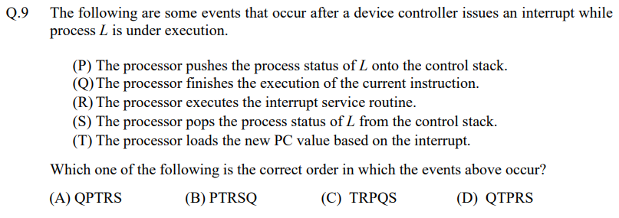

ANS: - A

# **Memory Management**

# **Cache Organization**

# **DISK**

# **Pipeline Processing**

# **Instruction & Addressing Mode**

# **CPU & Control Unit**